

**Rajshahi University of Engineering & Technology**

**Lab Report on   
Industrial Electronics Sessional  
ECE 3206**

**Submitted by**

**Deba Priyo Guha**

**Roll: 1810027**

**Department of Electrical & Computer Engineering**

**Rajshahi University of Engineering & Technology**

**Submitted to**

**Hafsa Binte Kibria**

**Lecturer**

**Department of Electrical & Computer Engineering**

**Rajshahi University of Engineering & Technology**

**Experiment No.**: 01

**Experiment Date**: 19/03/2023

**Experiment Name**: Study of Linear Convolution and Implement in Matlab

**Theory**:

In the same way as multiplication, addition, and integration are formal mathematical operations, so is convolution. While convolution uses two signals to create a third signal, addition uses two numbers to create a third number. Numerous mathematical disciplines, including probability and statistics, use convolution. The link between the input signal, the impulse response, and the output signal is described by convolution in linear systems.

The duration of x(n) is n1 samples in the range 0 n (n1 1) when two finite duration sequences, x(n) and h(n), are taken into consideration. The duration of h (n) is n2 samples, meaning that it is not zero outside of the range 0 to n (n2 1) only. The sequence y (n) defined as is produced by a periodic or linear convolution of x (n) and h (n).

It is obvious that y (n) is a finite duration series of samples of duration (n1+n2 -1). The steps listed below can be used to get the convolution sum of two sequences:

Step 1: Choosing an initial value for n, the moment at which the output sequence y (n) will be evaluated. N = n1+ n2-1 is a good choice if x(n) starts at n=n1 and h(n) starts at n=n2.

Putting both sequences in terms of the index m in step two.

Step 3: To obtain h (-m), fold h (m) about m=0 and shift h (n-m) by n to the right if n is positive or to the left if n is negative.

Step 4: Add the products of multiplying two sequences, x (n-m) and h (m), element by element to obtain y (n).

Step 5: Repeat steps 3 and 4 while increasing the index n and shifting the sequence x (n-m) to the right by one sample.

Step 6: Carry out step 5 again until the sum of products for all n-th values is zero.

**Software Used**:

Matlab

**Matlab Code**:

## **Without conv( ) function**:

**Code:**

clc;

clear all;

x=input('Enter the value of x :');

h=input('Enter the value of h :');

m=length(x);

m1=length(h);

subplot(2,2,1)

stem(x);

xlabel('n values');

ylabel('Amplitude');

title(' x(n) ');

subplot(2,2,2);

stem(h);

xlabel('n values');

ylabel('Amplitude');

title(' h(n) ');

X=[x,zeros(1,m)];

H=[h,zeros(1,m1)];

for i=1:(m1+m-1)

y(i)=0;

for j=1:m

if(i-j+1)>0

y(i)=y(i)+X(j)*H(i-j+1);

end

end

end

subplot(2,2,3);

stem(y);

xlabel('n values');

ylabel('Amplitude');

title(' y- output ');

## **Output** :

**Fig. 1:** Convolution of two signal output in Matlab without using conv( ) function

**Using Conv( ) function:**

**Code:**

clc;

clear all;

x=input('Enter the value of x :');

h=input('Enter the value of h :');

subplot(2,2,1)

stem(x);

xlabel('n values');

ylabel('Amplitude');

title(' x(n) ');

subplot(2,2,2);

stem(h);

xlabel('n values');

ylabel('Amplitude');

title(' h(n) ');

y= conv(x,h);

subplot(2,2,3);

stem(y);

xlabel('n values');

ylabel('Amplitude');

title(' y- output ');

**Output:**

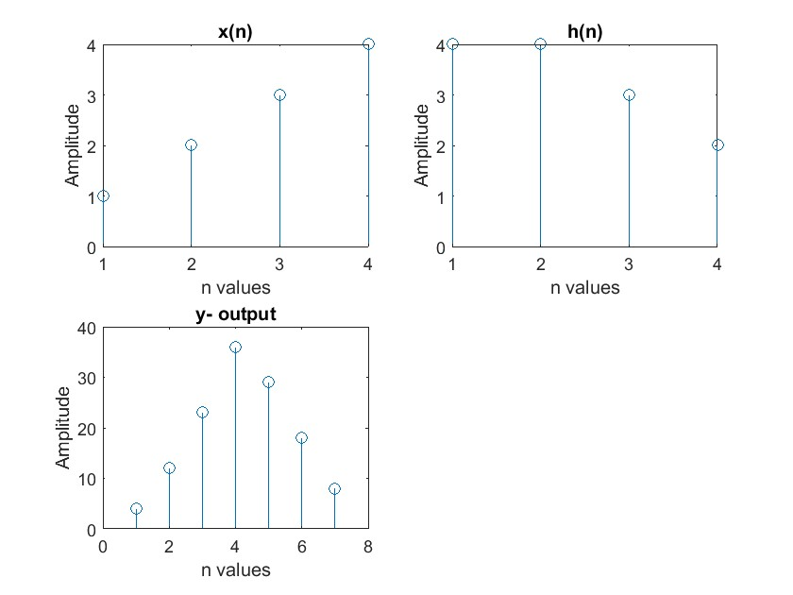

**Fig. 2:** Convolution of two signal output in Matlab using conv( ) function

**Discussion**:

Convolution of two discrete signals was to be implemented in the task. It was first carried out without utilizing the built-in convolution function conv(), and subsequently it was done using the function. And the outcome of the two using the same signal value is the same, as we can see in the experiment above. What we wanted was the experiment's outcome.

**Conclusion**:

The experiment was successful since the resulting signal agreed with the theory.